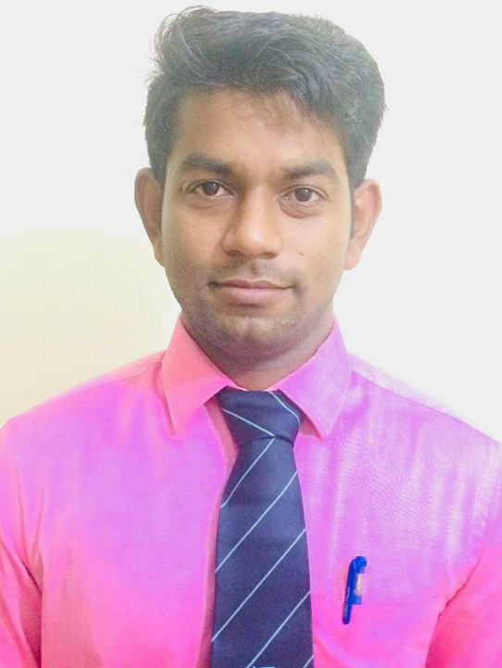

**CHARCHIT KUMAR SAHOO.**

C/o:Rabindra kumar sahoo.

At : Nuabazar,hariboliamatha,Paradeep

Po : Nuabazar,Paradeep

Dist: Jagatsinghpur, 754142

Mobile: +918908964069,9337098805

E-mail: [charchit10@gmail.com](mailto:charchit10@gmail.com)

**Career Objective**

To get a challenging position of lecturer in which I can utilize my experience and make the bright carrier of students.

**Career Summary**

* An innovative and knowledgeable professional having 1 years experience as a lecturer in capital institute of management science (CIMS).
* Proficient in developing new lessons and activities to expand learning opportunities.
* Extensive participation on committees and extra-curricular activities.
* Excellent knowledge of the subject and also has great practical knowledge.
* Proficient in giving conceptual knowledge.

**Personal Qualities**

* Excellent interpersonal skills.
* Strong analytical, logical and mathematical skills.
* Excellent communication skills in written and verbal both.
* Ability in clarifying the doubts.

**Key Responsibilities Handled**

* Employ differentiated teaching methods, incorporating, audio and visual activities to address all learning styles.
* Provide individualized instruction to keep all students at expected skill level.
* Identify and organize field trips to enhance curriculum.
* Meet with parents to discuss progress and address behavior or mastery issues.
* Develop discipline plans and work closely with at-risk students.

**Computer Knowledge**

* Proficient in basic use of computer.
* Post Graduate Diploma in Computer Application (PGDCA) & Tally 9.0

.

**Education Qualification**

* Post Graduation (M.com) pass out from Gangadhar Meher University,Sambalpur with 61% in the year 2016.
* Graduation (B.com) pass out from S.V.M (Auto) College , Jagatsinghpur

with 70% in the year 2013.

* Pass out +2commerce, from S.V.M (Auto) College, Jagatsinghpur with 57% in the year 2010.
* Pass out 10Th, from Municipal high school, Paradeep, with 59.62% in the year 2008.

**Personal Skill**

* Comprehensive problem solving abilities, excellent verbal and written communication skills, ability to deal with people diplomatically, willingness to hard worker, ability to lead a group and work in a group.

**STRENGTH**

* Interpersonal Skills
* Effective Communication Skills
* Effective Team Player

**Hobby**

* Playing Cricket
* Long Driving
* Listing Music

**Permanent details**

Name : CHARCHIT KUMAR SAHOO.

Father’s Name : Mr. Rabindra Kumar Sahoo.

Date of Birth : 15th July 1993

Gender : Male

Status : Unmarried

**DECLARATION**

I do hereby declare that above statements are made by me are true, correct and complete to the best of my knowledge and belief.

**Place**: Bhubaneswar **Charchit Kumar Sahoo**

**Date:**  (Signature)